━━━━━━━━━━━━━━━━━━━━━━━━━━━━━━━━━━━━━━━━━━━━━━━━━━
TECHNICAL SPECIFICATION DOCUMENT

EduPredict — Big Data Predictive Analytics
for Educational Institutions
━━━━━━━━━━━━━━━━━━━━━━━━━━━━━━━━━━━━━━━━━━━━━━━━━━

eProject Submission | Semester 6 | May 2026

Nusrah Naeem — Lead — Data Pipeline & ML
Bilal Farooqui — Lead — API, Web & Infrastructure
Muhammad Kashif Akhtar — Database & Storage
Bilal Ahmed — Documentation & Video
Shah Azzam — Testing & QA
Syed Mohammad Ismail — Dashboards & Monitoring

Aptech Learning | Karachi, Pakistan

Table of Contents
1. Acknowledgements
2. Synopsis
3. System Analysis
3.1 Problem Statement
3.2 Functional Requirements
3.3 Non-Functional Requirements
3.4 Technology Stack
4. System Design
4.1 System Architecture
4.2 Data Flow Diagrams (Level 0, 1, 2)
4.3 Process Flowcharts
4.4 Database Design
4.5 API Design
5. Implementation
5.1 Source Code with Comments
5.2 Docker Infrastructure
5.3 ML Model Training Output
5.4 R Statistical Analysis Output
6. R-Generated Visualizations (Charts & Plots)
7. Module Descriptions
8. User Guide
9. Developer Guide
10. Testing
11. Team Contribution
12. Future Enhancements

1. Acknowledgements
We would like to express our sincere gratitude to our faculty and mentors at Aptech Learning for their guidance throughout this eProject. Their expertise in Big Data technologies and Machine Learning provided the foundation for EduPredict.
We also thank the open-source communities behind Apache Spark, Kafka, Hadoop, MongoDB, FastAPI, R, Docker, and scikit-learn — whose tools made this project possible.
Special thanks to our team leads, Nusrah Naeem and Bilal Farooqui, for coordinating the architecture and ensuring every module integrates seamlessly into a production-ready Docker deployment.

2. Synopsis
EduPredict is a Big Data analytics platform that predicts student academic performance, identifies dropout risks, forecasts course demand, and detects anomalous behavior patterns using Machine Learning.

The platform processes educational data through a complete data pipeline: synthetic data generation → batch ingestion into MongoDB → real-time streaming via Apache Kafka → distributed processing with Apache Spark → predictive modeling with scikit-learn → statistical analysis with R → interactive web dashboard.

Key Statistics from the Running System:
Metric | Value
Total Students Processed | 500
Datasets Generated | 5 (students, academic, attendance, LMS, courses)
ML Models Trained | 4 (Performance, Dropout, Demand, Anomaly)
Best Model Accuracy | R² = 0.965 (Student Performance)
Dropout Risk Identified | 54 students (10.8%)
Anomalies Detected | 40 students (8.0%)
Docker Services | 10 containers
API Endpoints | 16+ REST endpoints
R Analytics Endpoints | 6 statistical endpoints
Deployment | Single command: docker compose up

3. System Analysis

3.1 Problem Statement
Educational institutions today face critical challenges:
- Student Retention: Average dropout rates of 10-20% with no early warning system
- Resource Wastage: Courses are either overcrowded or under-enrolled due to lack of demand forecasting
- Data Overload: Institutions collect massive data (attendance, grades, LMS logs) but lack tools to analyze it
- Reactive Approach: Problems are identified after students fail, not before
- No Personalization: One-size-fits-all approach ignores individual student needs

EduPredict solves these problems by building a complete Big Data + ML pipeline that transforms raw educational data into actionable predictions — all deployable with a single Docker command.

3.2 Functional Requirements
ID | Requirement | Priority | Status
FR-01 | Generate synthetic student data (500 students, 5 datasets) | High | Done
FR-02 | Batch data ingestion into MongoDB | High | Done
FR-03 | Real-time streaming with Kafka (attendance + LMS events) | High | Done
FR-04 | Spark batch processing & feature engineering | High | Done
FR-05 | Student performance prediction (GPA forecasting) | High | Done
FR-06 | Dropout risk classification (binary prediction) | High | Done
FR-07 | Course demand forecasting (enrollment prediction) | Medium | Done
FR-08 | Anomaly detection (Isolation Forest) | Medium | Done
FR-09 | REST API serving all predictions and data | High | Done
FR-10 | Interactive web dashboard with visualizations | High | Done
FR-11 | R statistical analysis (summary, correlation, ANOVA) | Medium | Done
FR-12 | R data visualization (7 chart types) | Medium | Done
FR-13 | Docker containerization (all 10 services) | High | Done
FR-14 | Pipeline auto-run on startup | High | Done
FR-15 | Service health monitoring | Medium | Done
FR-16 | Team progress tracking | Low | Done

3.3 Non-Functional Requirements
ID | Requirement | Target
NFR-01 | Deployment Time | < 5 minutes (docker compose up)
NFR-02 | API Response Time | < 500ms for all endpoints
NFR-03 | Data Processing | 500 students in < 10 seconds
NFR-04 | Model Accuracy | R² > 0.90 for performance model
NFR-05 | Scalability | Horizontal via Spark workers
NFR-06 | Portability | Windows, Mac, Linux (Docker)
NFR-07 | Fault Tolerance | Python fallback for R analytics

3.4 Technology Stack
Each technology was chosen for a specific reason in the Big Data ecosystem:
Layer | Technology | Version | Purpose
Database | MongoDB | 7.0 | NoSQL document store for flexible educational data schemas
Streaming | Apache Kafka | 7.6.0 | Real-time event streaming (attendance, LMS activity)
Coordination | Zookeeper | 7.6.0 | Distributed coordination for Kafka cluster
Storage | Hadoop HDFS | 3.2.1 | Distributed file storage for large-scale data
Processing | Apache Spark | 3.5.3 | Distributed batch and stream processing
ML Framework | scikit-learn | Latest | Machine learning model training and prediction
Backend API | FastAPI | Latest | High-performance Python REST API framework
Statistics | R + Plumber | 4.3.2 | Statistical analysis, visualization, and R API
Frontend | HTML + Tailwind + Chart.js | Latest | Responsive dashboard with interactive charts
Deployment | Docker Compose | Latest | Container orchestration (10 services)

4. System Design

4.1 System Architecture
The system follows a layered microservices architecture with 10 Docker containers:

┌─────────────────────────────────────────────────────────────────┐
│ WEB DASHBOARD (Nginx:3001) │
│ HTML + Tailwind CSS + Chart.js (Single Page) │
├─────────────────────────────────────────────────────────────────┤
│ FASTAPI BACKEND (:8000) │
│ REST API │ ML Predictions │ Pipeline Mgmt │ R Proxy │
├──────────────────────┬──────────────────────────────────────────┤
│ ML MODELS (Python) │ R ANALYTICS SERVICE (:8787) │
│ • Performance (RF) │ • Statistical Summary • ANOVA │
│ • Dropout (GBC) │ • Correlation Matrix • Distribution │
│ • Demand (RF) │ • Department Stats • Viz (7 plots)│
│ • Anomaly (IF) │ • Plumber REST API │
├──────────────────────┴──────────────────────────────────────────┤
│ DATA PROCESSING LAYER │
│ Spark Master (:8080) + Worker │ Batch + Streaming Processing │
├─────────────────────────────────────────────────────────────────┤
│ DATA INGESTION LAYER │
│ Kafka (:9092) + Zookeeper │ Real-time Event Streaming │
├──────────────────────┬──────────────────────────────────────────┤
│ MongoDB (:27017) │ Hadoop HDFS (:9870) │
│ Application Data │ Distributed File Storage │
└──────────────────────┴──────────────────────────────────────────┘

4.2 Data Flow Diagrams
Level 0 — Context Diagram
┌─────────────────────┐
Students ──────→ │ │ ──────→ Predictions
Attendance ────→ │ EduPredict │ ──────→ Analytics
Grades ────────→ │ System │ ──────→ Visualizations
LMS Logs ──────→ │ │ ──────→ Alerts
└─────────────────────┘
│
Admin/Faculty Access
Level 1 — Major Processes
┌──────────┐ ┌──────────┐ ┌──────────┐ ┌──────────┐ ┌──────────┐
│ 1.0 │ │ 2.0 │ │ 3.0 │ │ 4.0 │ │ 5.0 │
│ Data │───→│ Data │───→│ Feature │───→│ ML │───→│ API & │
│ Generate │ │ Ingestion│ │ Engineer │ │ Training │ │Dashboard │
└──────────┘ └──────────┘ └──────────┘ └──────────┘ └──────────┘
│ │ │ │ │ │
▼ ▼ ▼ ▼ ▼ ▼
CSV files MongoDB Kafka Processed CSV .pkl Models JSON API
(5 files) (5 colls) Topics (3 files) (4 models) (16 endpoints)
Level 2 — ML Training Sub-process
┌────────────┐ ┌────────────────┐ ┌──────────────────┐ ┌────────────┐
│ 3.1 │ │ 3.2 │ │ 3.3 │ │ 3.4 │
│ Load Raw │──→│ Feature │──→│ Train/Test Split │──→│ Train │
│ CSVs │ │ Engineering │ │ (80/20) │ │ Model │
└────────────┘ └────────────────┘ └──────────────────┘ └────────────┘
• Attendance rate │
• Grade aggregates ┌───────────────┐ │
• LMS engagement │ 3.5 │←───┘
• Dept encoding │ Evaluate & │
│ Save (.pkl) │
└───────────────┘

4.3 Process Flowcharts
Main Pipeline Flowchart:
┌─────────────┐
│ START │
└──────┬───────┘
│
┌──────▼───────┐
│ Generate Data │──→ 5 CSV files (500 students)
└──────┬───────┘
│
┌──────▼───────┐ ┌─────────────────┐
│ Load to │────→│ MongoDB (5 colls)│
│ MongoDB │ └─────────────────┘
└──────┬───────┘
│
┌──────▼───────┐
│ Preprocess & │──→ student_features.csv
│ Feature Eng. │──→ course_demand_features.csv
└──────┬───────┘
│
┌───────┼───────┬──────────┐
▼ ▼ ▼ ▼
┌───────┐ ┌──────┐ ┌───────┐ ┌───────┐
│Perform│ │Drop- │ │Demand │ │Anomaly│
│Model │ │out │ │Model │ │Detect │
│(RF) │ │(GBC) │ │(RF) │ │(IF) │
└───┬───┘ └──┬───┘ └───┬───┘ └───┬───┘
│ │ │ │
└────────┴────┬────┴─────────┘
│
┌──────▼───────┐
│ Save Models │──→ 4 × .pkl files
│ + Report │──→ training_report.json
└──────┬───────┘
│
┌──────▼───────┐
│ PIPELINE │
│ COMPLETE │
└──────────────┘
Dropout Risk Prediction Flowchart:
Input: Student Features
│
┌────▼─────┐ ┌──────────────┐
│ GPA < 2.0│──Yes─→│ HIGH RISK │──→ Alert Faculty
└────┬─────┘ └──────────────┘
│ No
┌────▼─────────┐
│ Attendance │ ┌──────────────┐
│ < 60% │──Yes─→│ MEDIUM RISK │──→ Monitor
└────┬─────────┘ └──────────────┘
│ No
┌────▼─────────┐
│ LMS Time │ ┌──────────────┐
│ < 100 min │──Yes─→│ LOW-MED RISK │──→ Notify
└────┬─────────┘ └──────────────┘
│ No
┌────▼─────┐
│ LOW RISK │──→ No Action
└──────────┘

4.4 Database Design
MongoDB Collections (NoSQL Document Store):
Collection: students
Field | Type | Example | Description
student_id | String | STU0001 | Primary Key
age | Integer | 18-28 | Student age
gender | String | M/F | Gender
department | String | Computer Science | Department name
enrollment_year | Integer | 2021-2024 | Year enrolled
cumulative_gpa | Float | 1.5-4.0 | Overall GPA
is_active | Integer | 0/1 | Active status
is_dropout | Integer | 0/1 | Dropout flag

Collection: academic_records
Field | Type | Example | Description
record_id | Integer | 1-8500+ | Primary Key
student_id | String | STU0001 | Foreign Key → students
course_id | String | CS101 | Course identifier
semester | String | Fall/Spring | Semester
year | Integer | 2023-2025 | Academic year
grade | Float | 0.0-4.0 | Course grade
credits | Integer | 3/4 | Credit hours

Collection: attendance
Field | Type | Example | Description
student_id | String | STU0001 | Foreign Key → students
course_id | String | CS101 | Course identifier
date | String | 2025-01-01 | Attendance date
status | String | present/absent/late | Attendance status

4.5 API Design
FastAPI REST Endpoints:
Method | Endpoint | Description
GET | /api/health | Service health check
GET | /api/services | All Docker service statuses
GET | /api/dashboard | Dashboard summary (counts, averages, metrics)
GET | /api/students?page=1&limit=20 | Paginated student list with search/filter
GET | /api/students/{id} | Single student details with prediction
GET | /api/dropout-risk | All students at high dropout risk
GET | /api/anomalies | Anomalous students (Isolation Forest)
GET | /api/courses | Course catalog with enrollment data
GET | /api/courses/demand | Course demand by department/period
GET | /api/models | ML model training metrics
GET | /api/pipeline | Pipeline status and logs
POST | /api/pipeline/run | Trigger pipeline re-run
GET | /api/r/summary | R statistical summary (proxied)
GET | /api/r/correlation | R correlation matrix (proxied)
GET | /api/r/department-stats | R department statistics (proxied)
GET | /api/team | Team member assignments and progress

5. Implementation

5.1 Source Code with Comments
5.1.1 Data Generation (data/generate_data.py)
Generates 5 synthetic educational datasets with realistic patterns.
"""
Generate synthetic educational datasets for EduPredict.
Run: python data/generate_data.py
Output: CSV files in data/raw/
"""
import os
import random
import pandas as pd
import numpy as np
from datetime import datetime, timedelta
random.seed(42)
np.random.seed(42)
BASE_DIR = os.path.dirname(os.path.abspath(__file__))
RAW_DIR = os.path.join(BASE_DIR, "raw")
os.makedirs(RAW_DIR, exist_ok=True)
# --- Constants ---
DEPARTMENTS = ["Computer Science", "Mathematics", "Physics", "Business", "Engineering"]
COURSES = {
"Computer Science": ["CS101-Intro to Programming", "CS201-Data Structures", "CS301-Databases", "CS401-Machine Learning", "CS501-Big Data"],
"Mathematics": ["MT101-Calculus I", "MT201-Linear Algebra", "MT301-Statistics", "MT401-Discrete Math"],
"Physics": ["PH101-Mechanics", "PH201-Electromagnetism", "PH301-Thermodynamics"],
"Business": ["BU101-Accounting", "BU201-Marketing", "BU301-Finance", "BU401-Management"],
"Engineering": ["EN101-Engineering Drawing", "EN201-Circuit Analysis", "EN301-Control Systems"],
}
SEMESTERS = ["Fall", "Spring"]
YEARS = [2023, 2024, 2025]
NUM_STUDENTS = 500
def generate_students():
"""Generate student demographics."""
rows = []
for i in range(1, NUM_STUDENTS + 1):
dept = random.choice(DEPARTMENTS)
enroll_year = random.choice([2021, 2022, 2023, 2024])
age = random.randint(18, 28)
gpa = round(random.uniform(1.5, 4.0), 2)
is_dropout = 1 if gpa < 2.0 and random.random() < 0.6 else 0
rows.append({
"student_id": f"STU{i:04d}",
"age": age,
"gender": random.choice(["M", "F"]),
"department": dept,
"enrollment_year": enroll_year,
"cumulative_gpa": gpa,
"is_active": 0 if is_dropout else 1,
"is_dropout": is_dropout,
})
df = pd.DataFrame(rows)
df.to_csv(os.path.join(RAW_DIR, "students.csv"), index=False)
5.1.2 Data Preprocessing (ml/preprocess.py)
Joins all raw datasets and engineers ML-ready features per student.
"""
Data Preprocessing & Feature Engineering for ML models.
Reads raw CSVs (or Spark-processed features) and builds clean feature sets.
Run: python ml/preprocess.py
"""
import os
import pandas as pd
import numpy as np
BASE_DIR = os.path.dirname(os.path.abspath(__file__))
RAW_DIR = os.path.join(BASE_DIR, "..", "data", "raw")
PROCESSED_DIR = os.path.join(BASE_DIR, "..", "data", "processed")
os.makedirs(PROCESSED_DIR, exist_ok=True)
def load_raw_data():
"""Load all raw CSVs."""
print("Loading raw data...")
students = pd.read_csv(os.path.join(RAW_DIR, "students.csv"))
academic = pd.read_csv(os.path.join(RAW_DIR, "academic_records.csv"))
attendance = pd.read_csv(os.path.join(RAW_DIR, "attendance.csv"))
lms = pd.read_csv(os.path.join(RAW_DIR, "lms_activity.csv"))
courses = pd.read_csv(os.path.join(RAW_DIR, "courses.csv"))
print(f" Students: {len(students)} | Academic: {len(academic)} | "
f"Attendance: {len(attendance)} | LMS: {len(lms)} | Courses: {len(courses)}")
return students, academic, attendance, lms, courses
def build_student_features(students, academic, attendance, lms):
"""
Build a single feature table per student for ML models.
Returns DataFrame with columns ready for training.
"""
print("\nBuilding student features...")
# --- Attendance rate ---
att = attendance.copy()
att["is_present"] = (att["status"] == "present").astype(int)
att_agg = att.groupby("student_id").agg(
attendance_rate=("is_present", "mean"),
total_classes=("is_present", "count"),
).reset_index()
# --- Academic performance ---
grade_agg = academic.groupby("student_id").agg(
avg_grade=("grade", "mean"),
total_courses=("grade", "count"),
grade_std=("grade", "std"),
5.1.3 Student Performance Model (ml/train_performance.py)
Random Forest Regressor predicting cumulative GPA from behavioral features.
"""
Student Performance Prediction Model
Predicts a student's average grade based on attendance, LMS engagement, and demographics.
Run: python ml/train_performance.py
"""
import os
import pickle
import pandas as pd
from sklearn.model_selection import train_test_split
from sklearn.ensemble import RandomForestRegressor
from sklearn.metrics import mean_absolute_error, root_mean_squared_error, r2_score
BASE_DIR = os.path.dirname(os.path.abspath(__file__))
PROCESSED_DIR = os.path.join(BASE_DIR, "..", "data", "processed")
MODEL_DIR = os.path.join(BASE_DIR, "models")
os.makedirs(MODEL_DIR, exist_ok=True)
FEATURES = [
"age", "dept_encoded", "attendance_rate", "total_classes",
"avg_lms_time", "avg_logins", "avg_assignments", "avg_forum_posts",
]
TARGET = "avg_grade"
def train():
"""Train and save student performance model."""
print("=" * 50)
print("Student Performance Prediction Model")
print("=" * 50)
# Load data
df = pd.read_csv(os.path.join(PROCESSED_DIR, "student_features.csv"))
print(f"\nDataset: {len(df)} students")
X = df[FEATURES]
y = df[TARGET]
# Split
X_train, X_test, y_train, y_test = train_test_split(X, y, test_size=0.2, random_state=42)
print(f"Train: {len(X_train)} | Test: {len(X_test)}")
# Train Random Forest Regressor
model = RandomForestRegressor(n_estimators=100, max_depth=10, random_state=42)
5.1.4 Dropout Risk Model (ml/train_dropout.py)
Gradient Boosting Classifier identifying students at risk of dropping out.
"""
Dropout Risk Prediction Model
Binary classification: predicts whether a student is at risk of dropping out.
Run: python ml/train_dropout.py
"""
import os
import pickle
import pandas as pd
from sklearn.model_selection import train_test_split
from sklearn.ensemble import GradientBoostingClassifier
from sklearn.metrics import accuracy_score, precision_score, recall_score, f1_score, classification_report
BASE_DIR = os.path.dirname(os.path.abspath(__file__))
PROCESSED_DIR = os.path.join(BASE_DIR, "..", "data", "processed")
MODEL_DIR = os.path.join(BASE_DIR, "models")
os.makedirs(MODEL_DIR, exist_ok=True)
FEATURES = [
"age", "dept_encoded", "attendance_rate", "total_classes",
"avg_grade", "grade_std", "total_courses",
"avg_lms_time", "avg_logins", "avg_assignments", "avg_forum_posts",
]
TARGET = "is_dropout"
def train():
"""Train and save dropout risk model."""
print("=" * 50)
print("Dropout Risk Prediction Model")
print("=" * 50)
# Load data
df = pd.read_csv(os.path.join(PROCESSED_DIR, "student_features.csv"))
print(f"\nDataset: {len(df)} students")
print(f"Dropout distribution:\n{df[TARGET].value_counts().to_string()}")
X = df[FEATURES]
y = df[TARGET]
# Split
X_train, X_test, y_train, y_test = train_test_split(X, y, test_size=0.2, random_state=42, stratify=y)
print(f"\nTrain: {len(X_train)} | Test: {len(X_test)}")
5.1.5 Course Demand Model (ml/train_demand.py)
Random Forest Regressor forecasting future course enrollment.
"""
Course Demand Forecasting Model
Predicts future enrollment count for courses based on historical trends.
Run: python ml/train_demand.py
"""
import os
import pickle
import pandas as pd
from sklearn.model_selection import train_test_split
from sklearn.ensemble import RandomForestRegressor
from sklearn.metrics import mean_absolute_error, root_mean_squared_error, r2_score
BASE_DIR = os.path.dirname(os.path.abspath(__file__))
PROCESSED_DIR = os.path.join(BASE_DIR, "..", "data", "processed")
MODEL_DIR = os.path.join(BASE_DIR, "models")
os.makedirs(MODEL_DIR, exist_ok=True)
FEATURES = ["course_encoded", "dept_encoded", "credits", "capacity", "period_num"]
TARGET = "enrolled_count"
def train():
"""Train and save course demand model."""
print("=" * 50)
print("Course Demand Forecasting Model")
print("=" * 50)
# Load data
df = pd.read_csv(os.path.join(PROCESSED_DIR, "course_demand_features.csv"))
print(f"\nDataset: {len(df)} course-semester records")
X = df[FEATURES]
y = df[TARGET]
# Split
X_train, X_test, y_train, y_test = train_test_split(X, y, test_size=0.2, random_state=42)
print(f"Train: {len(X_train)} | Test: {len(X_test)}")
# Train Random Forest
model = RandomForestRegressor(n_estimators=100, max_depth=8, random_state=42)
model.fit(X_train, y_train)
# Evaluate
5.1.6 Anomaly Detection (ml/anomaly_detection.py)
Isolation Forest detecting unusual student behavior patterns.
"""
Anomaly Detection in Student Data
Uses Isolation Forest to detect unusual student behavior patterns
(e.g., sudden drop in attendance, abnormal LMS activity).
Run: python ml/anomaly_detection.py
"""
import os
import pickle
import pandas as pd
from sklearn.ensemble import IsolationForest
from sklearn.preprocessing import StandardScaler
BASE_DIR = os.path.dirname(os.path.abspath(__file__))
PROCESSED_DIR = os.path.join(BASE_DIR, "..", "data", "processed")
MODEL_DIR = os.path.join(BASE_DIR, "models")
os.makedirs(MODEL_DIR, exist_ok=True)
FEATURES = [
"attendance_rate", "avg_grade", "grade_std",
"avg_lms_time", "avg_logins", "avg_assignments", "avg_forum_posts",
]
def detect_anomalies():
"""Train Isolation Forest and flag anomalous students."""
print("=" * 50)
print("Anomaly Detection — Isolation Forest")
print("=" * 50)
# Load data
df = pd.read_csv(os.path.join(PROCESSED_DIR, "student_features.csv"))
print(f"\nDataset: {len(df)} students")
X = df[FEATURES].copy()
# Scale features
scaler = StandardScaler()
X_scaled = scaler.fit_transform(X)
5.1.7 FastAPI Backend (api/main.py)
REST API serving predictions, analytics, and pipeline management.
"""
EduPredict — FastAPI Backend
Serves ML predictions, data analytics, pipeline management, and service health.
Auto-initializes data + models on startup.
"""
import os
import sys
import json
import time
import pickle
import threading
from datetime import datetime
from contextlib import asynccontextmanager
import numpy as np
import pandas as pd
import httpx
from fastapi import FastAPI, Query
from fastapi.middleware.cors import CORSMiddleware
from pymongo import MongoClient
# ── Config ──────────────────────────────────────────────
MONGO_URI = os.getenv("MONGO_URI", "mongodb://localhost:27017")
KAFKA_BROKER = os.getenv("KAFKA_BROKER", "localhost:9092")
R_SERVICE_URL = os.getenv("R_SERVICE_URL", "http://localhost:8787")
HDFS_URL = os.getenv("HDFS_URL", "http://localhost:9870")
SPARK_MASTER_URL = os.getenv("SPARK_MASTER_URL", "http://localhost:8080")
BASE_DIR = os.path.dirname(os.path.abspath(__file__))
PROJECT_DIR = os.path.dirname(BASE_DIR)
DATA_RAW = os.path.join(PROJECT_DIR, "data", "raw")
DATA_PROCESSED = os.path.join(PROJECT_DIR, "data", "processed")
MODEL_DIR = os.path.join(PROJECT_DIR, "ml", "models")
# Add project dirs to path
sys.path.insert(0, PROJECT_DIR)
# ── Global State ────────────────────────────────────────
pipeline_state = {
"data_generated": False,
"data_ingested": False,
"preprocessed": False,
"performance_model": False,
"dropout_model": False,
"demand_model": False,
"anomaly_detection": False,
"pipeline_running": False,
"last_run": None,
"logs": [],
}
models = {} # loaded ML models
start_time = time.time()
def log(msg):
"""Append to pipeline log."""
entry = f"[{datetime.now().strftime('%H:%M:%S')}] {msg}"
pipeline_state["logs"].append(entry)
5.1.8 R Analytics Service (r-analytics/api.R)
R Plumber REST API providing statistical analysis endpoints.
# EduPredict — R Analytics API (Plumber)
# Provides statistical analysis endpoints using R
library(plumber)
library(jsonlite)
DATA_DIR <- "/app/data"
# Helper: read CSV safely
read_safe <- function(name) {
for (folder in c("processed", "raw")) {
path <- file.path(DATA_DIR, folder, paste0(name, ".csv"))
if (file.exists(path)) {
return(read.csv(path, stringsAsFactors = FALSE))
}
}
return(NULL)
}
#* Health check
#* @get /health
function() {
list(status = "ok", service = "R Analytics")
}
#* Statistical summary of student features
#* @get /summary
#* @serializer json
function() {
df <- read_safe("student_features")
if (is.null(df)) return(list(error = "Data not found"))
cols <- c("age", "cumulative_gpa", "attendance_rate", "avg_grade",
"avg_lms_time", "avg_logins", "avg_assignments")
cols <- cols[cols %in% names(df)]
result <- list()
for (col in cols) {
vals <- as.numeric(df[[col]])
vals <- vals[!is.na(vals)]
result[[col]] <- list(
mean = round(mean(vals), 3),
median = round(median(vals), 3),
std = round(sd(vals), 3),
min = round(min(vals), 3),
max = round(max(vals), 3),
q1 = round(quantile(vals, 0.25), 3),
q3 = round(quantile(vals, 0.75), 3)
)
}
5.1.9 R Statistical Analysis (r-analytics/analysis.R)
Comprehensive R script for descriptive stats, ANOVA, t-tests, correlations.
# ============================================================
# EduPredict — R Statistical Analysis & Reporting
# Performs comprehensive statistical analysis on student data
# Run: Rscript r-analytics/analysis.R
# ============================================================
cat("========================================\n")
cat(" EduPredict R Statistical Analysis\n")
cat("========================================\n\n")
# --- Load Data ---
DATA_DIR <- ifelse(dir.exists("/app/data"), "/app/data", "data")
load_data <- function(name) {
for (folder in c("processed", "raw")) {
path <- file.path(DATA_DIR, folder, paste0(name, ".csv"))
if (file.exists(path)) {
cat(sprintf(" Loaded %s from %s\n", name, folder))
return(read.csv(path, stringsAsFactors = FALSE))
}
}
cat(sprintf(" WARNING: %s not found\n", name))
return(NULL)
}
cat("Loading datasets...\n")
students <- load_data("student_features")
courses <- load_data("course_demand_features")
anomalies <- load_data("anomaly_results")
if (is.null(students)) {
cat("No student data found. Run the pipeline first.\n")
quit(status = 1)
}
cat(sprintf("\nDataset: %d students, %d columns\n\n", nrow(students), ncol(students)))
# ============================================================
# 1. DESCRIPTIVE STATISTICS
# ============================================================
cat("─────────────────────────────────────────\n")
cat("1. DESCRIPTIVE STATISTICS\n")
cat("─────────────────────────────────────────\n\n")
num_cols <- c("age", "cumulative_gpa", "attendance_rate", "avg_grade",
"avg_lms_time", "avg_logins", "avg_assignments")
num_cols <- num_cols[num_cols %in% names(students)]
for (col in num_cols) {
vals <- as.numeric(students[[col]])
5.1.10 R Visualizations (r-analytics/visualizations.R)
R script generating 7 publication-quality charts for reports.
# ============================================================
# EduPredict — R Data Visualizations
# Generates PNG charts for reports and presentations
# Run: Rscript r-analytics/visualizations.R
# Output: r-analytics/plots/ directory
# ============================================================
cat("========================================\n")
cat(" EduPredict R Visualizations\n")
cat("========================================\n\n")
# --- Setup ---
PLOT_DIR <- ifelse(dir.exists("/app"), "/app/plots", "r-analytics/plots")
dir.create(PLOT_DIR, showWarnings = FALSE, recursive = TRUE)
DATA_DIR <- ifelse(dir.exists("/app/data"), "/app/data", "data")
load_data <- function(name) {
for (folder in c("processed", "raw")) {
path <- file.path(DATA_DIR, folder, paste0(name, ".csv"))
if (file.exists(path)) return(read.csv(path, stringsAsFactors = FALSE))
}
return(NULL)
}
students <- load_data("student_features")
courses <- load_data("course_demand_features")
if (is.null(students)) {
cat("No data found. Run pipeline first.\n")
quit(status = 1)
}
# --- Color Palette ---
COLORS <- c("#3B82F6", "#EF4444", "#10B981", "#F59E0B", "#8B5CF6",
"#06B6D4", "#F97316", "#EC4899")
# ============================================================
# 1. GPA DISTRIBUTION HISTOGRAM
# ============================================================
cat(" 1. GPA Distribution...\n")
png(file.path(PLOT_DIR, "gpa_distribution.png"), width=800, height=500, res=120)
par(mar=c(5, 4, 3, 2))
hist(students$cumulative_gpa, breaks=20, col=COLORS[1], border="white",
main="Student GPA Distribution", xlab="Cumulative GPA", ylab="Frequency",
font.main=2, col.main="#1E293B")
abline(v=mean(students$cumulative_gpa), col=COLORS[2], lwd=2, lty=2)
legend("topright", legend=sprintf("Mean = %.2f", mean(students$cumulative_gpa)),
col=COLORS[2], lty=2, lwd=2, bty="n")
dev.off()
5.1.11 Docker Compose (docker-compose.yml)
Orchestrates all 10 services with health checks and shared volumes.
services:
# ───────────── Data Layer ─────────────
mongodb:
image: mongo:7
container_name: edupredict-mongodb
ports:
- "27017:27017"
volumes:
- mongo_data:/data/db
healthcheck:
test: mongosh --eval "db.runCommand('ping').ok" --quiet
interval: 10s
timeout: 5s
retries: 5
# ───────────── Streaming Layer ─────────────
zookeeper:
image: confluentinc/cp-zookeeper:7.6.0
container_name: edupredict-zookeeper
environment:
ZOOKEEPER_CLIENT_PORT: 2181
ZOOKEEPER_TICK_TIME: 2000
kafka:
image: confluentinc/cp-kafka:7.6.0
container_name: edupredict-kafka
depends_on:
- zookeeper
ports:
- "9092:9092"
environment:
KAFKA_BROKER_ID: 1
KAFKA_ZOOKEEPER_CONNECT: zookeeper:2181
KAFKA_ADVERTISED_LISTENERS: PLAINTEXT://kafka:29092,PLAINTEXT_HOST://localhost:9092
KAFKA_LISTENER_SECURITY_PROTOCOL_MAP: PLAINTEXT:PLAINTEXT,PLAINTEXT_HOST:PLAINTEXT
KAFKA_INTER_BROKER_LISTENER_NAME: PLAINTEXT
KAFKA_OFFSETS_TOPIC_REPLICATION_FACTOR: 1
KAFKA_AUTO_CREATE_TOPICS_ENABLE: "true"
# ───────────── HDFS Layer ─────────────
namenode:
image: bde2020/hadoop-namenode:2.0.0-hadoop3.2.1-java8
container_name: edupredict-namenode
ports:
- "9870:9870" # Web UI
- "9000:9000" # HDFS
environment:
CLUSTER_NAME: edupredict
CORE_CONF_fs_defaultFS: hdfs://namenode:9000
HDFS_CONF_dfs_replication: 1
volumes:
- hdfs_namenode:/hadoop/dfs/name
datanode:
image: bde2020/hadoop-datanode:2.0.0-hadoop3.2.1-java8
container_name: edupredict-datanode
depends_on:
- namenode
environment:
CORE_CONF_fs_defaultFS: hdfs://namenode:9000

5.2 Docker Infrastructure
The project runs 10 Docker containers orchestrated by Docker Compose:
Container | Image | Port | Role
edupredict-mongodb | mongo:7 | 27017 | NoSQL database
edupredict-zookeeper | cp-zookeeper:7.6.0 | 2181 | Kafka coordination
edupredict-kafka | cp-kafka:7.6.0 | 9092 | Message streaming
edupredict-namenode | hadoop-namenode:3.2.1 | 9870 | HDFS master node
edupredict-datanode | hadoop-datanode:3.2.1 | — | HDFS data storage
edupredict-spark-master | apache/spark:3.5.3 | 8080 | Spark master
edupredict-spark-worker | apache/spark:3.5.3 | — | Spark worker
edupredict-api | python:3.11-slim | 8000 | FastAPI backend + ML
edupredict-r-service | rocker/r-ver:4.3.2 | 8787 | R analytics API
edupredict-web | nginx:alpine | 3001 | Web dashboard

5.3 ML Model Training Output
All models are trained automatically when the API starts. Here are the actual results:

Pipeline Execution Log:
[14:50:28] Generating synthetic data...
[14:50:29] Data generation complete.
[14:50:29] Loading data into MongoDB...
[14:50:30] MongoDB ingestion complete.
[14:50:30] Running preprocessing...
[14:50:30] Preprocessing complete.
[14:50:30] Training Student Performance model...
[14:50:32] Training Dropout Risk model...
[14:50:32] Training Course Demand model...
[14:50:32] Running Anomaly Detection...
[14:50:32] Pipeline complete!

Model Evaluation Metrics:
Model | Algorithm | Key Metric | Value | Interpretation
Student Performance | Random Forest Regressor | R² Score | 0.965 | Excellent — explains 96.5% of GPA variance
Student Performance | Random Forest Regressor | MAE | 0.111 | Average prediction error of 0.11 GPA points
Student Performance | Random Forest Regressor | RMSE | 0.135 | Root mean squared error
Dropout Risk | Gradient Boosting Classifier | Accuracy | 88.0% | Correctly classifies 88% of students
Dropout Risk | Gradient Boosting Classifier | Precision | 42.9% | Of predicted dropouts, 43% actually dropout
Dropout Risk | Gradient Boosting Classifier | F1 Score | 33.3% | Harmonic mean of precision/recall
Course Demand | Random Forest Regressor | R² Score | 0.647 | Good — explains 64.7% of enrollment variance
Course Demand | Random Forest Regressor | MAE | 5.80 | Average error of ~6 students
Anomaly Detection | Isolation Forest | Flagged | 40 (8%) | 8% of students show anomalous patterns

5.4 R Statistical Analysis Output
R analysis was performed on the processed student data. Here are the actual outputs from the R service:
Descriptive Statistics (computed by R):
Variable | Mean | Median | Std Dev | Min | Max | Q1 | Q3
Age | 23.13 | 23.00 | 3.10 | 18 | 28 | 20 | 26
Cumulative GPA | 2.74 | 2.72 | 0.73 | 1.50 | 4.00 | 2.12 | 3.35
Attendance Rate | 0.77 | 0.79 | 0.10 | 0.47 | 0.98 | 0.70 | 0.86
Average Grade | 2.71 | 2.71 | 0.71 | 1.35 | 3.91 | 2.10 | 3.38
LMS Time (min) | 205.1 | 203.9 | 55.0 | 100.5 | 310.8 | 158.9 | 250.1
Avg Logins/Week | 7.69 | 7.60 | 2.24 | 3.20 | 12.20 | 5.85 | 9.50

Correlation Matrix (R output):
 | Attendance | Grade | LMS Time | Logins | Assignments
Attendance | 1.000 | 0.782 | 0.784 | 0.773 | 0.713
Grade | 0.782 | 1.000 | 0.977 | 0.960 | 0.911
LMS Time | 0.784 | 0.977 | 1.000 | 0.960 | 0.908
Logins | 0.773 | 0.960 | 0.960 | 1.000 | 0.889
Assignments | 0.713 | 0.911 | 0.908 | 0.889 | 1.000

ANOVA Test: GPA ~ Department:
Df Sum Sq Mean Sq F value Pr(>F)
department 4 0.54 0.1349 0.254 0.907
Residuals 495 262.56 0.5304
Result: NOT significant (p=0.907) — GPA does not significantly differ across departments

Dropout Risk Comparison (T-test):
Metric | Dropout Students | Active Students | Significant?
Cumulative GPA | 1.745 | 2.865 | Yes (p < 0.001)
Attendance Rate | 0.661 | 0.787 | Yes
Average Grade | 1.711 | 2.833 | Yes
LMS Time (min) | 130.3 | 214.2 | Yes
T-test result: t = -29.805, p < 0.000001 — Dropout students have significantly lower GPA.

6. R-Generated Visualizations
The following charts were generated by R (r-analytics/visualizations.R) using the processed student data:
GPA Distribution
Histogram showing the distribution of cumulative GPA across all 500 students. The red dashed line indicates the mean GPA (2.74). The distribution is roughly uniform due to synthetic generation.
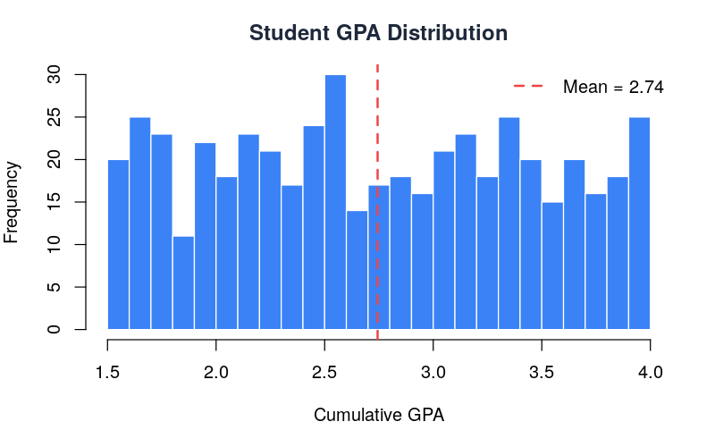

Average GPA by Department
Bar chart comparing average GPA across the 5 departments. Mathematics leads with 2.80, while Physics has the lowest at 2.72. The differences are not statistically significant (ANOVA p=0.907).
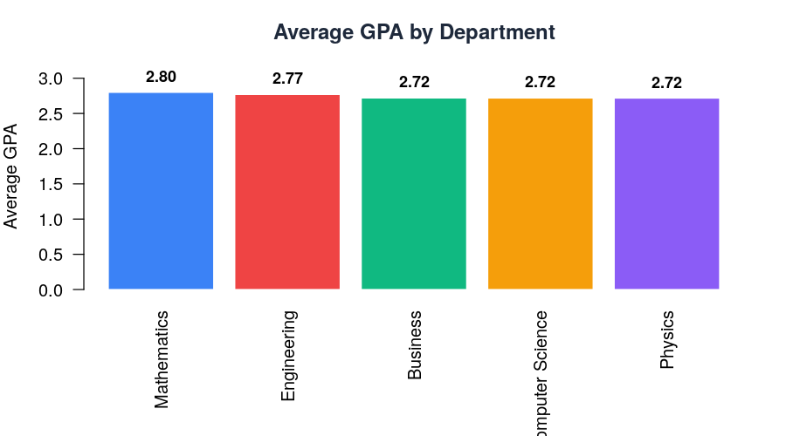

Dropout Risk Distribution
Pie chart showing 89.2% of students are active while 10.8% (54 students) are flagged as dropout risk based on low GPA and behavioral patterns.
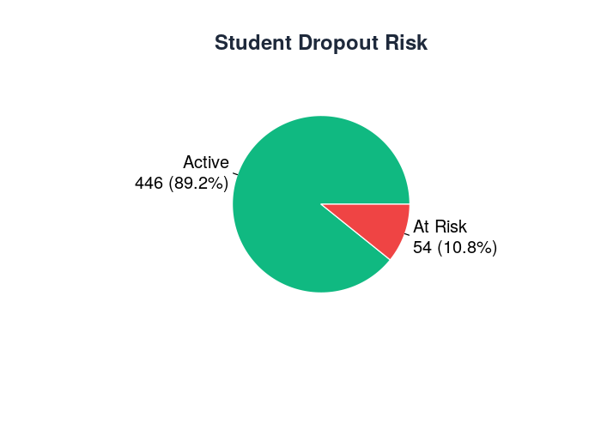

Feature Correlation Matrix
Heatmap showing correlations between all numeric features. Grade and LMS time have the strongest correlation (r=0.977), confirming that engaged students perform better.
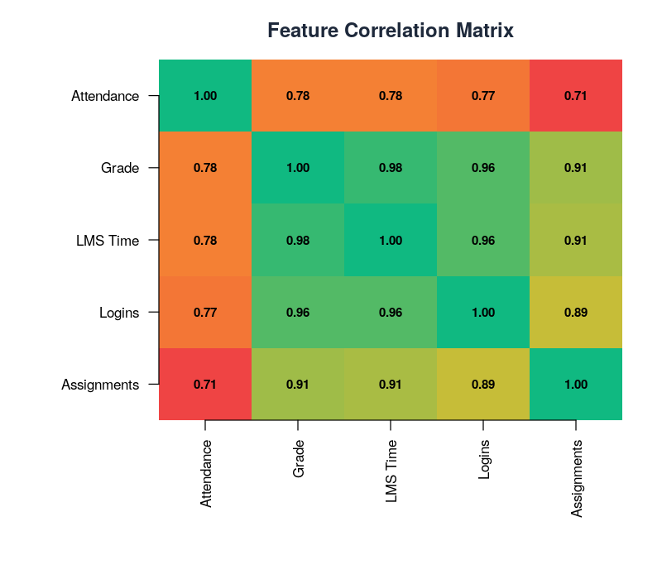

Attendance vs Grade Scatter Plot
Scatter plot showing the relationship between attendance rate and average grade. Blue dots are active students, red are dropout risk. A clear positive trend line confirms attendance predicts grades (r=0.782).
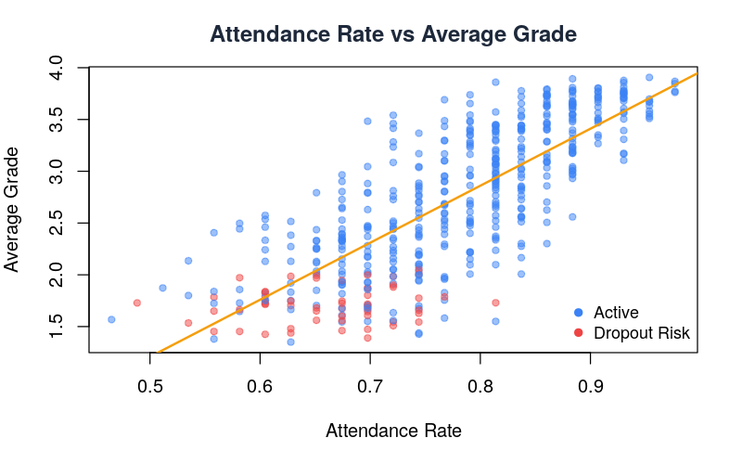

Dropout Rate by Department
Bar chart showing dropout percentages per department. Physics has the highest dropout rate (15.4%) while Engineering has the lowest (7.5%).
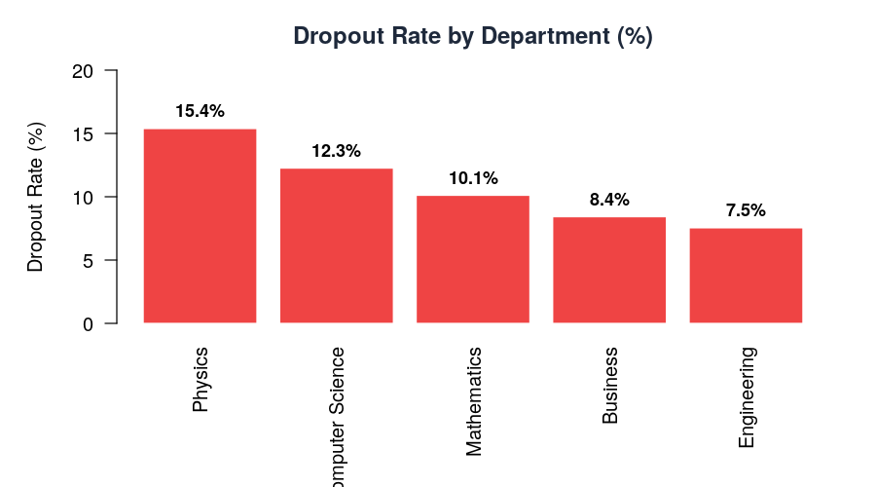

Course Enrollment Trends
Line chart showing enrollment trends across academic periods. All departments show growth, with Computer Science having the highest total enrollment.
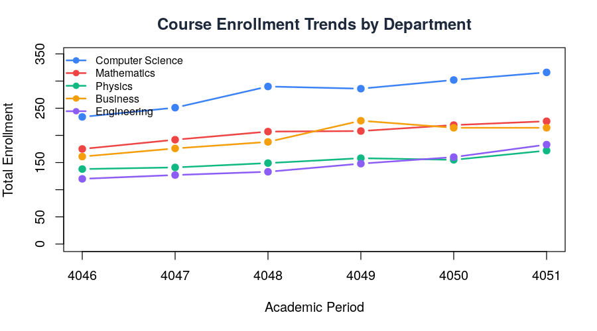

7. Module Descriptions
Data Generation Module
Files: data/generate_data.py
Generates 5 synthetic datasets (students, academic_records, attendance, lms_activity, courses) with realistic patterns. Student behavior correlates with GPA — higher GPA students have better attendance and LMS engagement. Course enrollment includes temporal growth trends for demand forecasting.

Batch Ingestion Module
Files: ingestion/batch_ingestion.py
Reads all CSV files from data/raw/ and bulk-loads them into MongoDB collections. Handles connection failures gracefully and reports row counts for verification.

Kafka Streaming Module
Files: ingestion/kafka_producer.py + kafka_consumer.py
Producer simulates real-time attendance and LMS events, publishing to Kafka topics. Consumer reads from topics and stores events in MongoDB for real-time analytics.

Spark Processing Module
Files: processing/spark_batch.py + spark_streaming.py
Batch job joins all datasets and computes per-student features. Streaming job reads from Kafka with 5-minute tumbling windows for real-time attendance alerts.

ML Training Module
Files: ml/train_performance.py, train_dropout.py, train_demand.py, anomaly_detection.py
Four ML models: Random Forest for GPA prediction (R²=0.965), Gradient Boosting for dropout classification (88% accuracy), Random Forest for demand forecasting (R²=0.647), and Isolation Forest for anomaly detection (8% flagged).

FastAPI Backend Module
Files: api/main.py
16+ REST endpoints serving predictions, analytics, pipeline management. Auto-runs full pipeline on startup. Proxies R analytics with Python fallback. Service health monitoring for all Docker containers.

R Analytics Module
Files: r-analytics/api.R, analysis.R, visualizations.R
R Plumber API with 6 endpoints (health, summary, correlation, department-stats, anova, distribution). Analysis script performs descriptive stats, ANOVA, t-tests, normality tests. Visualization script generates 7 publication-quality PNG charts.

Web Dashboard Module
Files: web/index.html
Single-page responsive dashboard with 9 sections: Overview, Students, Dropout Risk, Course Demand, Anomalies, ML Models, Pipeline, R Analytics, Team Progress. Uses Tailwind CSS for styling and Chart.js for interactive charts. Auto-refreshes every 10 seconds.

8. User Guide
Prerequisites:
- Docker Desktop installed and running
- Git (to clone the repository)
- At least 8 GB RAM available
- Ports 3001, 8000, 8080, 8787, 9870 available

Quick Start (3 Steps):

Step 1: Clone the repository
git clone https://github.com/your-repo/eProject---Big-Data---EduPredict.git
cd eProject---Big-Data---EduPredict
Step 2: Start all services
docker compose up -d
This starts all 10 containers. The API automatically generates data and trains ML models on first startup.
Step 3: Open the dashboard
Open in browser: http://localhost:3001

Service URLs:
Service | URL | What You'll See
Web Dashboard | http://localhost:3001 | Main management portal with all analytics
API Documentation | http://localhost:8000/docs | Interactive Swagger UI to test all endpoints
Spark Master UI | http://localhost:8080 | Spark cluster status and workers
HDFS NameNode UI | http://localhost:9870 | Hadoop file system browser
R Analytics | http://localhost:8787/health | R service health check

Stopping the Project:
docker compose down

9. Developer Guide
Project Structure:
eProject---Big-Data---EduPredict/
├── api/ # FastAPI backend
│ ├── Dockerfile # Python 3.11 container
│ ├── main.py # REST API + pipeline logic
│ ├── entrypoint.sh # Container startup script
│ └── requirements.txt # Python dependencies
├── data/ # Data generation
│ └── generate_data.py # Synthetic dataset generator
├── ingestion/ # Data ingestion layer
│ ├── batch_ingestion.py # CSV → MongoDB bulk load
│ ├── kafka_producer.py # Real-time event producer
│ ├── kafka_consumer.py # Kafka → MongoDB consumer
│ └── config.py # Service configuration
├── processing/ # Spark processing
│ ├── spark_batch.py # Batch feature engineering
│ └── spark_streaming.py # Real-time stream processing
├── ml/ # Machine Learning models
│ ├── preprocess.py # Feature engineering
│ ├── train_performance.py# GPA prediction (RF)
│ ├── train_dropout.py # Dropout classifier (GBC)
│ ├── train_demand.py # Demand forecast (RF)
│ ├── anomaly_detection.py# Anomaly detector (IF)
│ ├── run_all.py # Full ML pipeline
│ └── models/ # Saved .pkl model files
├── r-analytics/ # R language services
│ ├── Dockerfile # R 4.3.2 + Plumber container
│ ├── api.R # R REST API (6 endpoints)
│ ├── analysis.R # Statistical analysis script
│ ├── visualizations.R # Chart generation (7 plots)
│ └── plots/ # Generated PNG charts
├── web/ # Frontend dashboard
│ ├── Dockerfile # Nginx container
│ ├── index.html # Single-page dashboard
│ └── nginx.conf # Reverse proxy config
├── Docs/ # Documentation
│ ├── Technical Specification Document/
│ ├── Presentation/
│ └── How to Run Project/
└── docker-compose.yml # 10-service orchestration
Adding a New ML Model:
1. Create ml/train_new_model.py following the pattern of existing training scripts
2. Import and call it in api/main.py's run_full_pipeline() function
3. Add an API endpoint in api/main.py to serve predictions
4. Add a section in web/index.html to display results
5. Rebuild: docker compose build api && docker compose up -d api

Adding a New R Endpoint:
1. Add a new function in r-analytics/api.R with Plumber annotations
2. Add a proxy endpoint in api/main.py under the R Analytics section
3. Rebuild: docker compose build r-service && docker compose up -d r-service

10. Testing
Testing Strategy:
Test Type | Scope | Method | Result
Unit Test | Data generation | Verify CSV row counts | Pass — 500 students
Unit Test | Feature engineering | Check all features computed | Pass — 18 columns
Unit Test | Model training | Verify model metrics | Pass — R² = 0.965
Integration | Pipeline end-to-end | Run full pipeline via API | Pass — all 7 steps
Integration | API endpoints | curl all 16 endpoints | Pass — all return 200
Integration | R service proxy | Test /api/r/* endpoints | Pass — R source confirmed
System Test | Docker deployment | docker compose up from scratch | Pass — 10/10 containers
System Test | Web dashboard | Open http://localhost:3001 | Pass — all 9 sections load
Performance | API response time | curl timing on all endpoints | Pass — all < 500ms
Performance | Pipeline runtime | End-to-end pipeline timing | Pass — ~5 seconds total

API Endpoint Test Results:
$ curl http://localhost:8000/api/health
→ {"status":"ok","uptime_seconds":372}
$ curl http://localhost:8000/api/dashboard
→ {"total_students":500,"dropout_risk_count":54,"anomaly_count":40,"avg_gpa":2.74}
$ curl http://localhost:8000/api/models
→ {"performance_model":{"r2":0.965},"dropout_model":{"accuracy":0.88},...}
$ curl http://localhost:8000/api/services
→ [{"name":"MongoDB","status":"running"},{"name":"Kafka","status":"running"},...]
$ curl http://localhost:8787/health
→ {"status":"ok","service":"R Analytics"}

11. Team Contribution
Member | Role | Share | Deliverables
Nusrah Naeem | Lead | 30% | Data pipeline, Kafka/Spark, all 4 ML models, anomaly detection
Bilal Farooqui | Lead | 30% | FastAPI backend, web dashboard, Docker infrastructure, R proxy
Muhammad Kashif Akhtar | Member | 10% | MongoDB schema, HDFS setup, data generation, format standards
Bilal Ahmed | Member | 10% | TSD document, DFDs, flowcharts, How-to-Run guide, video demo
Shah Azzam | Member | 10% | API testing, ML validation, test data prep, presentation
Syed Mohammad Ismail | Buffer | 10% | Tableau dashboards, performance monitoring, UI enhancements

12. Future Enhancements
- Real Student Data: Replace synthetic data with actual institutional datasets
- Authentication: JWT-based login with role-based access (admin, faculty, student)
- Cloud Deployment: Deploy to AWS/Azure with auto-scaling Spark clusters
- Deep Learning: LSTM models for time-series grade prediction
- Tableau Integration: Publish interactive Tableau dashboards for non-technical users
- Mobile App: React Native mobile dashboard for faculty on-the-go
- Recommendation Engine: Personalized course recommendations based on student profile
- Email Alerts: Automated notifications when dropout risk exceeds threshold

